End Rhyme

🔹 What is End Rhyme
# Source: AI Source: Provided by: [Data Path: Persons Table -> ID Column: 1, Name_En Column: Motasem Essam] -> From: [Chatgpt (GPT-4-turbo)] on [8/2/2025]
⚠️ End rhyme is a poetic sound device, not a formal type of homograph, but homographs may coincidentally participate in end rhyme.

✅ Definition of End Rhyme
# Source: AI Source: Provided by: [Data Path: Persons Table -> ID Column: 1, Name_En Column: Motasem Essam] -> From: [Chatgpt (GPT-4-turbo)] on [8/2/2025]
End rhyme occurs when the final syllables or sounds of two or more lines in poetry rhyme with each other.
It is the most common rhyme in poetry and often used to establish rhythm and pattern.

🔊 Key Feature
# Source: AI Source: Provided by: [Data Path: Persons Table -> ID Column: 1, Name_En Column: Motasem Essam] -> From: [Chatgpt (GPT-4-turbo)] on [8/2/2025]
- Rhyming words appear at the end of lines in a poem.
- Can include perfect, slant, eye, or other rhyme types.

📝 Examples of End Rhyme in Poetry

✅ Example (Perfect End Rhyme):
# Source: AI Source: Provided by: [Data Path: Persons Table -> ID Column: 1, Name_En Column: Motasem Essam] -> From: [Chatgpt (GPT-4-turbo)] on [8/2/2025]

I wandered lonely as a cloud
That floats on high o'er vales and shroud.
Words: cloud / shroud → final sounds rhyme perfectly.

✅ Example with Homographs in End Rhyme:
# Source: AI Source: Provided by: [Data Path: Persons Table -> ID Column: 1, Name_En Column: Motasem Essam] -> From: [Chatgpt (GPT-4-turbo)] on [8/2/2025]
The wind began to blow
And scattered leaves below the row.
Word row (homograph: /roʊ/ as line; /raʊ/ as fight) shares sound with blow → Perfect end rhyme.

🧠 How Homographs Relate to End Rhyme
# Source: AI Source: Provided by: [Data Path: Persons Table -> ID Column: 1, Name_En Column: Motasem Essam] -> From: [Chatgpt (GPT-4-turbo)] on [8/2/2025]
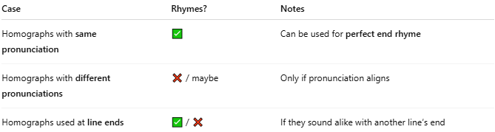
Case | Rhymes? | Notes
Homographs with same pronunciation | ✅ | Can be used for perfect end rhyme
Homographs with different pronunciations | ❌ / maybe | Only if pronunciation aligns
Homographs used at line ends | ✅ / ❌ | If they sound alike with another line’s end

📊 Comparison Table
# Source: AI Source: Provided by: [Data Path: Persons Table -> ID Column: 1, Name_En Column: Motasem Essam] -> From: [Chatgpt (GPT-4-turbo)] on [8/2/2025]
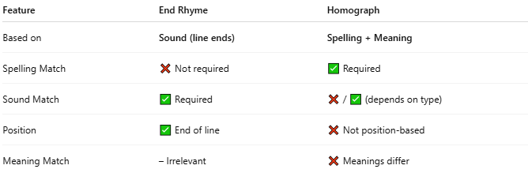
Feature | End Rhyme | Homograph
Based on | Sound (line ends) | Spelling + Meaning
Spelling Match | ❌ Not required | ✅ Required
Sound Match | ✅ Required | ❌ / ✅ (depends on type)
Position | ✅ End of line | ❌ Not position-based
Meaning Match | – Irrelevant | ❌ Meanings differ

🔁 Common Overlap
# Source: AI Source: Provided by: [Data Path: Persons Table -> ID Column: 1, Name_En Column: Motasem Essam] -> From: [Chatgpt (GPT-4-turbo)] on [8/2/2025]
Sometimes, homographs are used at line ends and happen to rhyme—creating end rhyme coincidentally.
For example:
- “Lead” (metal) rhyming with “dead”
- “Read” (past tense) rhyming with “red”

✅ Conclusion
# Source: AI Source: Provided by: [Data Path: Persons Table -> ID Column: 1, Name_En Column: Motasem Essam] -> From: [Chatgpt (GPT-4-turbo)] on [8/2/2025]
- End rhyme is not a type of homograph but a rhyme position in poetry.
- Homographs can appear in end rhymes if their pronunciation matches rhyming lines.
- Especially relevant in poetry, songwriting, and phonetic wordplay.

